

**select min(status) from s;**



**select max(weight) from p;**



**select avg(weight) from p;**



**SELECT SUM(Qty) FROM SPJ**

**WHERE `P#` = 'p1';**



**SELECT `P#`,SUM(QTY) FROM SPJ**

**group by `P#`;**



**SELECT `P#`,AVG(QTY) FROM SPJ**

**group by `P#`;**



**SELECT `P#`,MAX(QTY) FROM SPJ**

**group by `P#`**

**HAVING MAX(QTY) > 800;**



**select status,count(*) "Count" from s**

**group by status;**



**select count(jname) from j;**



**select count(status) - count(*) from s;**

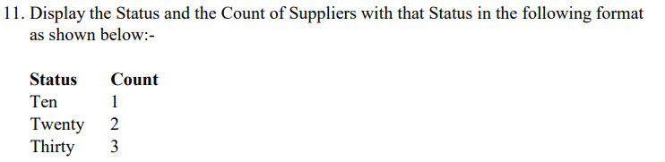

**select * from j;**

**SELECT**

**CASE**

**WHEN STATUS = 10 THEN 'TEN'**

**WHEN STATUS = 20 THEN 'TWENTY'**

**WHEN STATUS = 30 THEN 'THIRTY'**

**WHEN STATUS = 40 THEN 'FORTY'**

**END "STATUS",**

**count(*) "Count"**

**from s**

**group by Status**

**order by 1;**